**Cathkin High School**

**English Department**

**S2 Reading and Language Support Booklet**

**[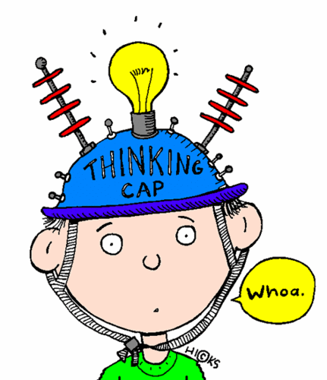](http://www.google.co.uk/url?sa=i&rct=j&q=homework+clip+art&source=images&cd=&ved=0CAcQjRw&url=http://www.clipartpanda.com/categories/math-homework-paper-clipart&ei=VSgAVfOtGMarUdDZgfAK&psig=AFQjCNEvujCP4PxiNBes7mTg3E-YOtPMUQ&ust=1426160074995270)**

**Name:**

**Class:**

**In Your Dreams**

[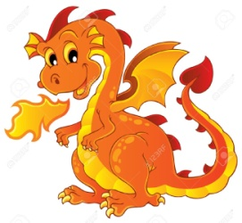](http://www.google.co.uk/url?sa=i&rct=j&q=dream+dragon+clip+art&source=images&cd=&cad=rja&uact=8&ved=0CAcQjRw&url=http://www.123rf.com/clipart-vector/cartoon_dragon.html&ei=kSwAVbXzHZHzaoq4gIAE&psig=AFQjCNGRBddAUCoDuLGCamKW9vG2E_GBtg&ust=1426161144182048)

Charlotte kept having a horrible dream. In it, she wasn’t Charlotte at all, but a princess who had been captured by a huge and ferocious dragon and was being kept prisoner in its cave. Brave heroes had tried to rescue her, but the dragon had eaten them all and had scattered their bones on the cave floor.

The dream was terrifying and Charlotte had dreamed it every night for weeks now. It was such a relief to wake up and find herself in her ordinary bed, in her ordinary house, with ordinary mum and dad in the next room. If only the nightmare would stop, she thought, she’d never grumble that life was boring again!

Someone had told her that if you went to bed really tired, you were less likely to dream, so all day she had deliberately done lots of energetic things. But as soon as she fell asleep… (From *Short and Spooky* by Louise Cooper)

1. What is the problem with Charlotte?

2. What adjective tells the reader what her dream is like?

3 How is she different in the dream?

4. What is happening to her in the dream?

5. How does the writer make the image of the cave seem scarier?

6. How long has she been having this dream?

7. Why does the writer repeat the word ‘ordinary’?

8. What had she been grumbling about before?

9. What did she do to try and stop dreaming?

10. Why does the writer put the three dots at the end of the sentence?

**The Wolf** **[](http://www.google.co.uk/url?sa=i&rct=j&q=wolf+clip+art&source=images&cd=&ved=0CAcQjRw&url=http://www.clker.com/clipart-140727.html&ei=DiwAVZSXC4zhaqTZgvgD&psig=AFQjCNHysOA-PCxwnrcE-Qrb70lE69ipkw&ust=1426161031129995)**

The wolf’s yellow eye is large and round, with a black pupil in the middle. And it never blinks. The boy could be watching a candle flame in the dark. It grows fatter and rounder like a harvest moon in an empty sky. But what really matters is the pupil. The black pupil. You wanted to stare at me, it seems to be saying, so go ahead, stare at me! It sparkles so brightly, it’s scary. Like a flame.

The boy stays where he is. He doesn’t look away. Slowly, Black Flame allows her muscles to relax. After a while she whispers between her fangs, “Fine, we’ll make a deal. You can stare as much as you like but don’t disturb me while I’m teaching the little ones – is that clear?”

All around them lies the snow. It stretches as far as the hills on the horizon. The silent snow of Alaska in the Far North. Black Flame’s voice rises solemnly out of the white silence. “Children, today I’m going to talk to you about human beings.”

(From *Eye of the Wolf* by Daniel Pannac)

1. What is unusual about the wolf’s eye?

2. What does the writer compare it to?  
3. What is this technique called?

4. Why is ‘the black pupil’ a single sentence?

5. What word describes how bright it is?

6. How does the writer make the boy seem brave?

7. What is the wolf’s name?

8. Explain why the setting is effective.

9. What is ‘silent snow’ an example of?

10. What word describes the way the wolf speaks?

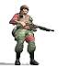**The War**

It was dark, but there was a moon. The ruins in front of them glowed blue. Jake raised his hand to halt his squad of fighters. He ducked behind a wall and watched the squad following his orders quickly and without a sound. Ten hard soldiers in helmets and body armour, their faces painted green and black. His squad, ready to fight even when they were worn out.

Jake looked at his communications man. His real name was Gary, but the squad called him Tiny because he was so big. Not many kids made it to Tiny’s size by the time they were twelve. Not many kids make it to the age of twelve at all these days, thought Jake.

Tiny’s fingers clicked over the computer’s keys, putting in the security code and their squad number. A face came up on screen, an old man with silver hair and cold blue eyes.

(From *Alien* by Tony Bradman)

1. Explain when the story is taking place.

2. Where is the light coming from?

3. What colour is it?

4. How do we know that Jake is the leader?

5. How many soldiers does he have?

6. What are they wearing?

7. How does the reader know that they are tired?

8. Explain how Tiny got his name.

9. Where is the onomatopoeia in the last paragraph?

10. How is the description of the old man effective?

**Music Practice**

The next afternoon as Chelsea was practising her saxophone, the front door opened and her mother came bursting into the living room.

Her hair was drenched, her raincoat soaked through. Chelsea raised her eyes to the window and saw that it was as black as night outside and pouring rain. She had been concentrating so hard on her music, she hadn’t even been aware of the rainstorm.

Chelsea gasped when she saw that her mother’s white uniform was stained with dark red blood. “Mum – what happened?” she cried. “We had a little accident at the home. One of the patients slipped in the bath and got cut. It looks much worse than it was.”

As her mother changed into a clean uniform, Chelsea told her about the new boy in her class, how they went for a walk and how he seemed shy but nice. Mrs Richards, pulling on the starched white uniform seemed very pleased. “Can’t wait to meet him,” she told Chelsea, smiling.

(From *First Date* by R.L.Stine)

1. What is Chelsea doing?

2. What words describe her mother’s entrance?

3. What does ‘drenched’ tell the reader about the rain?

4. What is ‘black as night’ an example of?

5. Why was she not aware of the rainstorm?

6. Why does she gasp?

7. Where does her mother work?

8. Explain how the writer tells us what her job is.

9. What two adjectives describe the new boy in her class?

10. How does the reader know her mother is ‘very pleased’?

The Secret of City Cemetery

That’s why he was beside himself with glee when he saw city workmen digging graves at the edge of the public cemetery. They were paupers’ graves, intended for persons whose families couldn’t afford the fancy plots near the centre of the cemetery. Several graves were dug before winter frost would make digging difficult. Willard knew they would be filled in as needed.

He was clever enough to see that the part of the cemetery where the graves had been dug was located next to the playground of Mark Twain Middle School. The sidewalk leading into the school playground and up to the front entrance ran beside the freshly dug graves. There was no way a kid could go in or out of the playground or school building without passing by the graves.

When weather permitted, smaller neighbourhood children always played in the schoolyard till dark. Willard didn’t believe in ghosts. But he knew most of the kids did. He counted on that.

(From *The Secret of City Cemetery* by Patrick Bone)

1. What does the word ‘glee’ mean?

2. Who were digging graves?

MCj02506060000[1]3. Who were the paupers?

4. What made digging difficult?

5. Which word is used to describe Willard?

6. Where were the new graves located?

7. What would the children have to pass before entering school?

8. What do you understand by the phrase, ‘When weather permitted’?

9. What did Willard not believe in?

10. What did Willard count on?

**The King’s College**

When William had first received my letter telling him of my plans to make this trip to Aberdeen, and asking if I might lodge with him, he had taken it as a sign that I had emerged from that black tunnel of despair that I had hidden myself in since my disgrace. He had written back to me almost instantly, suggesting that we should seek out some old friends of our student days who were to be in the Old Town at the time of my visit. My first impulse had been to say no, I could not face it, but Jaffray dissuaded me from being so hasty. Now the meeting no longer filled me with dread. Indeed the thought of seeing those friends again gave me some pleasure. "I will be glad to see them," I said. "But as for the morning, I mean to use it to examine your uncle’s notebooks. Jaffray is sure that if the flower used to poison Patrick Davidson is to be found, it will be found there."

"Then you must use my study. The light there is the best in the house, and it is the room furthest from the kitchen, so you will have peace. What these women find to gossip and cackle about all day long, I do not know. I am sure old Duncan only pretends at deafness to save himself having to listen to them. Is that not right, Duncan?"

1. Who does the narrator write to?

2. Which metaphor describes the narrator after his disgrace?

3. Explain what ‘almost instantly’ means.

4. Where were the old friends going to be?

5. Explain what ‘dissuaded’ means.

6. What was used to poison Patrick?

7. Name two benefits the study has.

8. Choose another word for ‘peace’.

9. What do the women do all day?

10. Who is pretending to be deaf?

**Riding the Silver Wave**

He ran into the water and plunged into a wave. I just stood there and watched, not knowing what to do. Then I lost him and I wondered if I should follow or go for help. Ratso had vanished too. I panicked. I thought they had both drowned, then suddenly the waves parted and I saw them: Craig thrashing through the water; Ratso too far out and in trouble.

I didn’t think twice after that. Craig was going to need all the help he could get and I knew it. I flung myself onto my board and paddled as fast as I could, but I was only halfway out when I saw Ratso go under. A wave rolled over me and I came up just in time to see Craig pull him up again. Then another wave hit me and I lost sight of them.

I suppose I should have known. I suppose I should have realized something was very wrong when I saw the boy sitting cross-legged on his board. The waves didn’t seem to touch him. He was drifting through them like they weren’t even there, but he had his back to me so I couldn’t see him properly. It was only when I was closer that I noticed how thin and skinny he was. Only then did I notice his hair was like plaited seaweed and that his surfboard was glowing electric blue in the water.

(From *Riding the Silver Wave* by Ben Bo)

1. Which verb describes how he entered the water?

2. Name the dilemma facing the narrator.

3. What does the narrator think has happened to the two boys?

4. What does the narrator fling himself on to?

5. Where is the narrator when Ratso goes under?

6. What happens when the second wave hits the narrator?

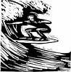7. When does the narrator realize something is wrong?

8. Why could the narrator not see ‘him’ properly?

9. Write one adjective which describes this strange boy.

10. Which simile describes the boy’s hair?

**Charlie and the Chocolate Factory**

There is something about very cold weather that gives one an enormous appetite. Most of us find ourselves beginning to crave rich steaming stews and hot apple pies and all kinds of delicious warming dishes; and because we are all a great deal luckier than we realize, we usually get what we want- or near enough. But Charlie Bucket never got what he wanted because the family couldn’t afford it, and as the cold weather went on and on, he became ravenously and desperately hungry. Both bars of chocolate, the birthday one and the one Grandpa Joe had bought, had long since been nibbled away, and all he got now were those thin, cabbagy meals three times a day.

Then all at once, the meals became even thinner.

The reason for this was that the toothpaste factory, the place where Mr Bucket worked, suddenly went bust and had to close down. Quickly, Mr Bucket tried to get another job. But he had no luck. In the end, the only way in which he managed to earn a few pennies was by shovelling snow in the streets. But it wasn’t enough to buy even a quarter of the food that seven people needed. The situation became desperate. Breakfast was a single slice of bread for each person now, and lunch was maybe half a boiled potato.

(From *Charlie and the Chocolate Factory* by Roald Dahl)

1. What does very cold weather do to people?

2. Name two dishes people crave in this weather.

3. Why was Charlie not as lucky as most people?

4. Write down two words to describe how hungry Charlie was.

5. Where did the two bars of chocolate come from?

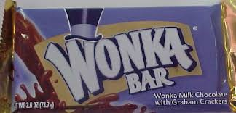6. How often does Charlie get ‘cabbagy meals’?

7. Where did Mr Bucket used to work?

8. Why does Mr Bucket need to look for another job?

9. How many people does Mr Bucket need to feed?

10. What does each person have for breakfast?

**Imagery Revision**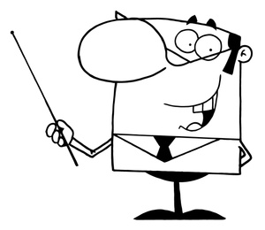

In the following sentences an example of imagery has been used. Beside each, write the correct type.

Choose from: simile, metaphor, personification, alliteration or onomatopoeia.

1. The law’s as tricky as a ten-foot snake.
2. Pike, three inches long, perfect pike in all parts.
3. The hissing geese were a terror.
4. The sea is a hungry dog.
5. Lights blinked along the runway.
6. Her hair was a gleaming helmet of copper.
7. Hunger stalked the land.
8. The scientist said the exploding bomb was ‘as bright as a thousand suns.’
9. The whizz of the Catherine wheel startled us.
10. ‘I heard the owl scream and the crickets cry,’ said Lady Macbeth.

**Harry Potter and the Philosopher’s Stone**

Harry had never been to London before. Although Hagrid seemed to know where he was going, he was obviously not used to getting there in an ordinary way. He got stuck in the ticket barrier on the Underground, and complained loudly that the seats were too small and the trains too slow. "I don't know how the Muggles manage without magic," he said as they climbed a broken-down escalator that led up to a bustling road lined with shops.  
  
Hagrid was so huge that he parted the crowd easily; all Harry had to do was keep close behind him. They passed book shops and music stores, hamburger restaurants and cinemas, but nowhere that looked as if it could sell you a magic wand. This was just an ordinary street full of ordinary people. Could there really be piles of wizard gold buried miles beneath them? Were there really shops that sold spell books and broomsticks? Might this not all be some huge joke that the Dursleys had cooked up?

If Harry hadn't known that the Dursleys had no sense of humour, he might have thought so; yet somehow, even though everything Hagrid had told him so far was unbelievable, Harry couldn't help trusting him. "This is it," said Hagrid, coming to a halt, "the Leaky Cauldron. It's a famous place."

For a famous place, it was very dark and shabby. A few old women were sitting in a corner, drinking tiny glasses of sherry. One of them was smoking a long pipe. A little man in a top hat was talking to the old bartender, who was quite bald and looked like a toothless walnut. The low buzz of chatter stopped when they walked in. Everyone seemed to know Hagrid; they waved and smiled at him, and the bartender reached for a glass, saying, "The usual, Hagrid?" "Can't, Tom, I'm on Hogwarts business," said Hagrid, clapping his great hand on Harry's shoulder and making Harry's knees buckle.  
  
"Good Lord," said the bartender, peering at Harry, "is this? Can this be?" The Leaky Cauldron had suddenly gone completely still and silent. "Bless my soul," whispered the old bartender, "Harry Potter... what an honor." He hurried out from behind the bar, rushed toward Harry and seized his hand, tears in his eyes. "Welcome back, Mr. Potter, welcome back!" Harry didn't know what to say. Everyone was looking at him. The old woman with the pipe was puffing on it without realizing it had gone out.  
  
Hagrid was beaming. Then there was a great scraping of chairs and the next moment, Harry found himself shaking hands with everyone in the Leaky Cauldron. "Doris Crockford, Mr. Potter, can't believe I'm meeting you at last." "So proud, Mr. Potter, I'm just so proud." "Always wanted to shake your hand, I'm all of a flutter." "Delighted, Mr. Potter; just can't tell you, Diggle's the name, Dedalus Diggle." "I've seen you before!" said Harry, as Dedalus Diggle's top hat fell off in his excitement. "You bowed to me once in a shop." "He remembers!" cried Dedalus Diggle, looking around at everyone. "Did you hear that? He remembers me!" Harry shook hands again and again; Doris Crockford kept coming back for more.

A pale young man made his way forward, very nervously. One of his eyes was twitching. "Professor Quirrell!" said Hagrid. "Harry, Professor Quirrell will be one of your teachers at Hogwarts." "P-P-Potter," stammered Professor Quirrell, grasping Harry's hand, "c-can't t-tell you how p- pleased I am to meet you." "What sort of magic do you teach, Professor Quirrell." "D-Defense Against the D-D-Dark Arts," muttered Professor Quirrell, as though he'd rather not think about it. "N-not that you n-need it, eh, P-P-Potter?" He laughed nervously. "You'll be g-getting all your equipment, I suppose. I've g-got to p-pick up a new b-book on vampires, m-myself." He looked terrified at the very thought.  
  
But the others wouldn't let Professor Quirrell keep Harry to himself. It took almost ten minutes to get away from them all. At last, Hagrid managed to make himself heard over the babble. "Must get on -- lots ter buy. Come on, Harry." Doris Crockford shook Harry's hand one last time, and Hagrid led them through the bar and out into a small, walled courtyard, where there was nothing but a trash can and a few weeds.  
  
Hagrid grinned at Harry. "Told yeh, didn't I? Told yeh you was famous.”



1. What did Hagrid complain about on the way to London?
2. Which types of shop did Harry and Hagrid pass on their way through London?
3. What is the name of the pub they enter before going to Diagon Alley?
4. What did the pub look like?
5. How does J. K. Rowling describe the bartender?
6. Who did he meet in the pub?
7. Who has Harry met before? Can you explain why Harry remembers him?
8. What do we learn about Professor Quirrell in this extract?
9. How is Hagrid portrayed in this extract?
10. How is Harry portrayed in this extract?

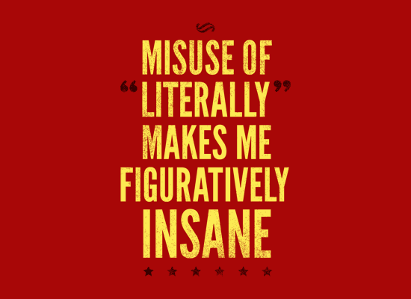

Literally V Figuratively

The confusion between these two words can create some infuriating mistakes in everyday life. Let’s look at the definitions and then we can make sure that we are always using this to inform or creative writing and help us to understand other texts as well.

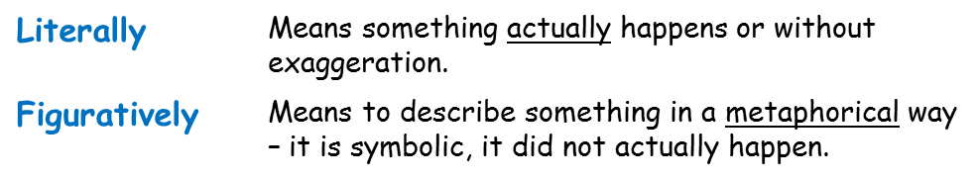

Are these literal or figurative sentences. Explain why underneath.

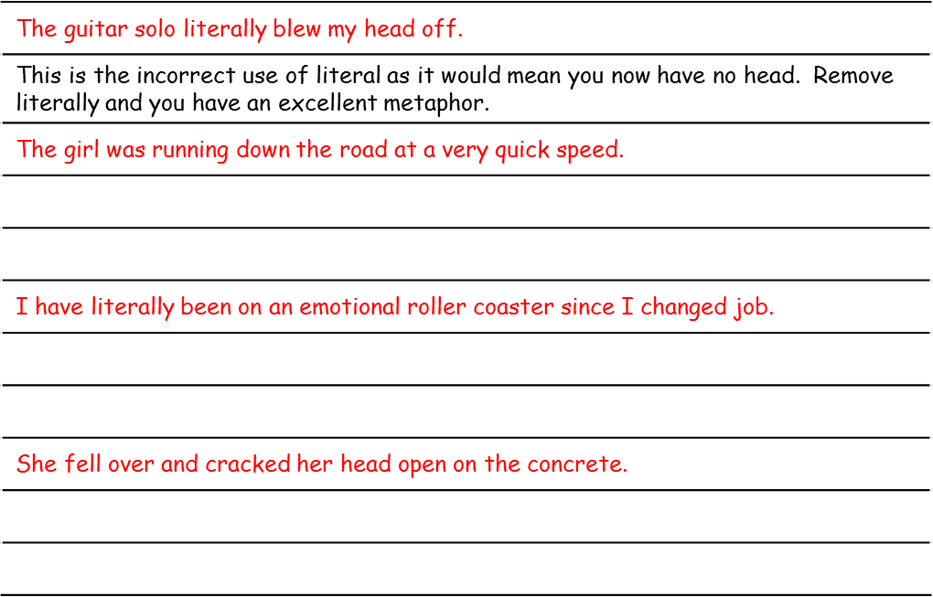

An idiom is a short phrase that describes something in a figurative way –it is infrequently used to describe something literally.

You have probably heard them in everyday conversation but now you know their real name you can wow someone with your new knowledge!

Speaking figuratively...

Idioms



**Why do I need to know this?**

1. It can help you improve your creative writing by adding in metaphorical language.
2. It will help you analyse a text – idioms will make you think about what they are trying to tell us below the surface – not just the literal meaning.

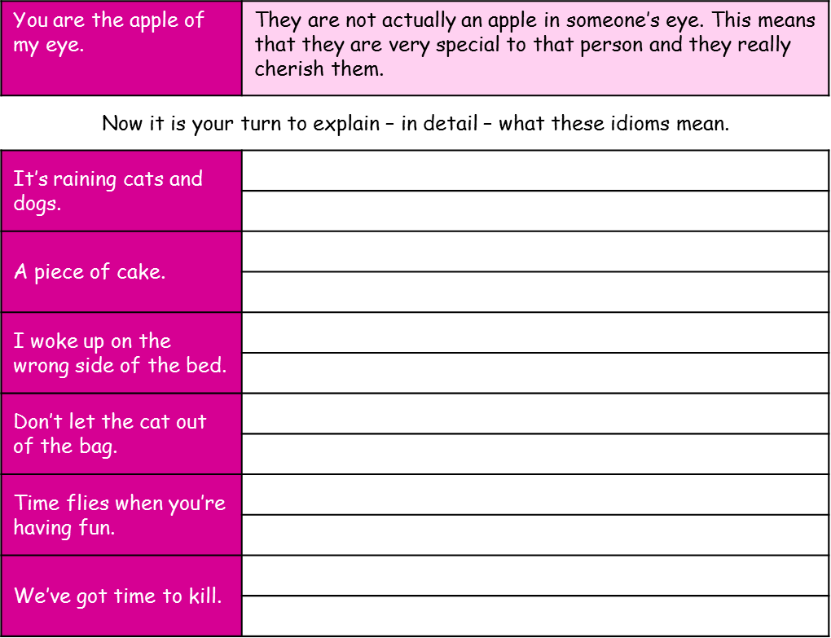

**Tricks & Techniques**

**A reminder**

**[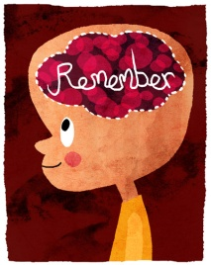](http://www.google.co.uk/url?sa=i&rct=j&q=remember&source=images&cd=&cad=rja&uact=8&ved=0CAcQjRw&url=http://robinyap.com/?p=3856&ei=nzAAVa3SCo3uaqjAgogL&psig=AFQjCNG5yxbKCLjGgxWk4cWps4fbMGTc2Q&ust=1426162178323001)**

Make sure you know, can spot and comment on the effect of the following techniques:

**Simile** – a comparison using the words ‘as’ or ‘like’

**Metaphor** – a comparison when one thing is said to be another

**Alliteration**- the repetition of a letter sound within a group of words

**Onomatopoeia** – a sound word.

**Personification** – when an inanimate object is given human characteristics or qualities.